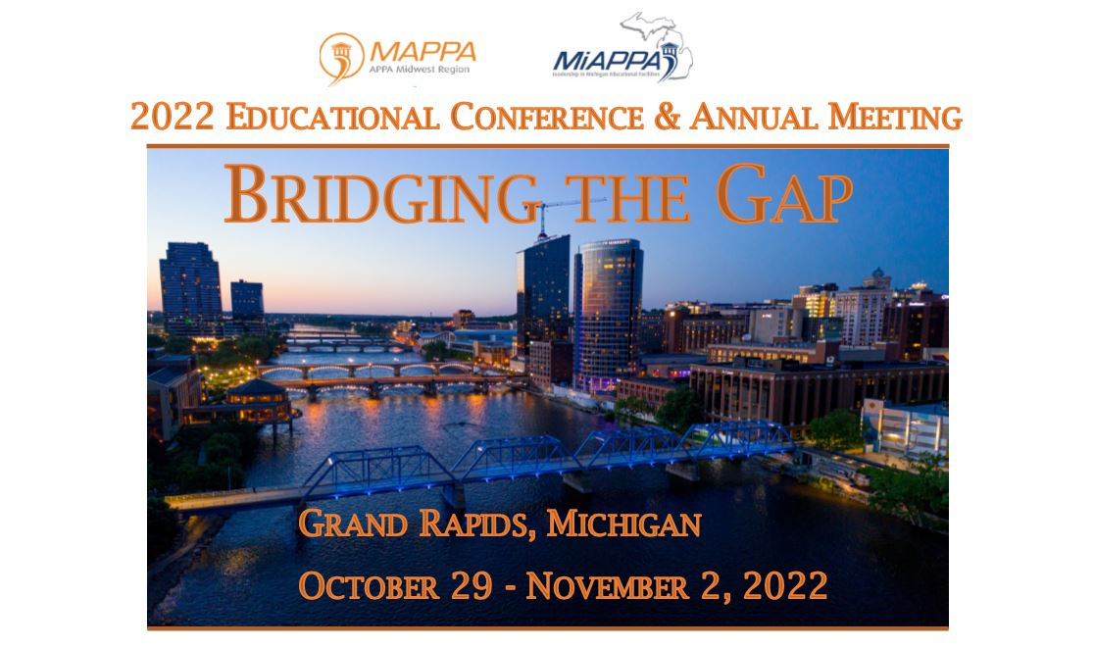
Monday, October 31, 2022 – Wednesday, November 2, 2022
Supervisor Toolkit & Academy on Campus Level 1 –
River Overlook Rooms E – Supervisor Toolkit
River Overlook Rooms F – Academy on Campus
(Breakfast and Lunch – in the hallway by classrooms)

MAPPA / MiAPPA 2022 Conference Agenda:
Monday, October 31, 2022
- Vendor move in – and set up by 3 p.m. Ballroom C/D
- Registration (Vendor) 8:00 a.m. – 3:00 p.m. – Secchia Lobby (Entrance to ballroom C/D)
- Registration (Conference attendees) 12:00 – 5:00 p.m. – Secchia Lobby (Entrance to Ballroom A/B)
3:00 p.m. – 4:00 p.m. Decision Makers / Sponsor “Speed Dating”
4:00 p.m. – 4:30 p.m. Vendor Welcome DeVos Place Ballroom C/D
4:30 p.m. – 5:30 p.m. First Time Attendee Reception – DeVos Place Ballroom C/D
5:30 – 7:30 p.m. MAPPA Welcome Reception 5:30 p.m. – 7:30 p.m.
Bar and hors d'oeuvres in Ballroom C/D in the vendor area

Tuesday, November 1, 2022
7:00 a.m. Breakfast and registration Ballroom A/B
8:00 a.m. Welcome and Keynote speaker
9:15 a.m. Educational Session 1 - Riverview Overlook Rooms
A | B | C | D
Campus Placemaking: Filling a Gap in Properties with Partnerships, Pedestrians and Art  Karen Ingle,  Grand Valley State University | Designing for Human Behavior  Joe Agati  Agati Furniture | Preventative Maintenance (PM) vs Restoration /Repair/Replacement (3R’s)  Leo Gusfa  ServPro | Nanobubbles: Tiny Fighters of Your Biggest Cost and Energy Wasters  Pete Strazdas  Western Michigan University  Dave DeVree  Rapid Water Technologies
Supervisor Toolkit – Riverview Overlook Room E & Academy on Campus – Riverview Overlook Room F
10:15 a.m. Break – refreshments outside River Overlook
10:45 a.m. Educational Session 2 - Riverview Overlook Rooms
A | B | C | D
Solidifying Community Presence for Lifelong Learners: Bringing New Opportunities Through Consolidation, Sustainable Spaces & Utilizing Community Assets  Grand Rapids Community College and  David Wilkins  GMB Architecture & Engineering | A Path for High Performance Cleaning  Brandon Baswell  Michigan State University | Overcoming Facility Operations Challenges: Building Intelligence, Knowledge Continuity, and Emergency Response Planning.  Western Michigan University  Matt Wandrie  Belfor | Using UV-C to Improve Indoor Air Quality and Lower Your Energy Bill  Jess Kota  Sterile-Aire
Supervisor Toolkit – Riverview Overlook Room E & Academy on Campus – Riverview Overlook Room F
11:45 a.m. – 2:15 p.m. Vendor Networking / Lunch Ballroom A – D
2:15 p.m. Educational Session 3 -Riverview Overlook Room
A | B | C | D
Will Flexible Work Actually Save Space?  Andrew Sama  Huron Consulting Group | Reimagining Student Services to Bridge the Gap in Achieving Student Success  Rebecca Celis  HGA | Aligning Hiring Teams for Advancement  Marc Datz  Helbling & Associates | Validating and Budgeting Your Essential Service  Jill Kegler  Janitorial Manager
Supervisor Toolkit – Riverview Overlook Room E & Academy on Campus – Riverview Overlook Room F
3:15 p.m. Break – refreshments outside River Overlook or down in Vendor area
3:30 p.m. Educational Session 4 - Riverview Overlook Room
A | B | C | D
Decarbonization Solutions and Master Planning for a Sustainable and Resilient Campus  James Leidel  DTE | Bridging the Gap – While Adding to the Mission  Gateway Technical College  Thomas Huberty  Trane Technologies | Bridging Student Occupancy Gaps: Best Practices for Maintaining Building Water Systems During Low to No Use  Hilary Nardone  Barclay Water Management, Inc. | Compound Your Energy Savings! Reduce Service Calls and Improve Your Facilities Management Strategy with Monitoring Based Commissioning  Pete Strazdas  Western Michigan University  Mark Wisz  dbHMS
Supervisor Toolkit – Riverview Overlook Room E & Academy on Campus – Riverview Overlook Room F
4:00 p.m. – Vendor break down
5:30 p.m. – 7:30 p.m. – Awards Ceremony/Reception at 20 Monroe

Wednesday, November 2, 2022
7:00 a.m. Breakfast and registration Ballroom A/B
8:00 a.m. Keynote Speaker 2
9:00 a.m. Large School Session Ballroom A/B
Small School Session Ballroom C/D
10 a.m. Break – refreshments outside River Overlook
10:15 a.m. Educational Session 5 - Riverview Overlook Room
A | B | C | D
Workshop: Closeouts that Work – For YOU and Your Staff  Ariel Castillo  Miller Davis Company | Building for the New Normal: How Actionable Facilities Data and Master Plans Help Bridge the Gap to Meet New (Everchanging) Needs.  Sarah Hempstead  Schmidt Associates | Developing a Pathway to Campus Sustainability  Jake Smith  Centrica Business Solutions | Meet Your Next Custodian – The Autonomous Floor Cleaner  Brandon Baswell  Michigan State University  Glen Huizenga  Nichols
Supervisor Toolkit – Riverview Overlook Room E & Academy on Campus – Riverview Overlook Room F

11:15 a.m. Educational session 6 - Riverview Overlook Room
A | B | C | D
Grand Valley State University – Interprofessional Simulation Center: From Vision to Reality  Katie Branch  Grand Valley State University  Bill Rapson  Fishbeck | Audiovisual Equity for Learning Environments  Robert Hnasko  HGA | Design Considerations for Small Scale (<20 MW) Heat Recovery Steam Generators  Kimberly Garcia  Cleaver-Brooks | Solutions for Project Construction Escalation  Thad Berkes  Design Collaborative
Supervisor Toolkit – Riverview Overlook Room E & Academy on Campus – Riverview Overlook Room F

12:15 p.m. Lunch Ballroom A/B (Roundtables)
River Overlook Rooms E – Supervisor Toolkit
River Overlook Rooms F – Academy on Campus

1:30 p.m. – 3:30 p.m. Tours
- GVSU Health Campus – Simulation Center
- GVSU Seidman College of Business, GVSU
- Innovation and Design HUB, GVSU
- Kendall College - Ferris
3:30 p.m. – Close of conference

