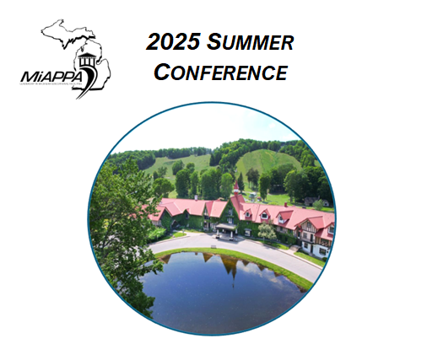
Boyne Highlands
July 16 – 18, 2025
Conference Theme: Evolving Facilities:
A Mountain of Change

Place checkmark(s) by the best description of the presenter format for your proposed workshop:

- delivered by an individual (for panel /group, skip to next section)
____ an Educational Institution Facilities Professional
____ a Business Partner
- delivered by a group or panel of
  - ____ Educational Institution Facilities Professionals
  - ____ Business Partner(s)
Second, carefully review and complete each section in this application. The last page includes your instructions to submit. The deadline is April 25, 2025. Final selection outcomes will be e-mailed by May 5, 2025.
Questions directly related to this proposal, or the conference are to be directed to Michelle Holstege (Contact information on last page).
Presenter Name If group or panel, list the PRIMARY presenter/organizer
Title
Institution / Company
Email Address
Best daytime telephone number
Title of Presentation
Presenters must provide their own laptop. A projector & screen will be provided. If sound or web access is essential to your presentation, describe your needs in this section. (Otherwise leave blank = no sound or web needed).
Presentation Experience
In this section, tell us about your past experience with the development & delivery of time-limited presentations to groups. If this is your first presentation, summarize your interest, content expertise & how you will prepare timing & delivery.

ABSTRACT (150 word max)
Provide an overview of your presentation. Your abstract will be used in program materials.

IMPACT & LEARNING OUTCOMES
Who is the ideal audience for this presentation? How does your topic expand, improve, innovate the knowledge and understanding of MiAPPA participants? Please note activities, case studies, simulations or other experiential techniques will be used in this session. Details are encouraged.

Biography (100 words or less about the Primary Presenter) Co-presenter/group members discussed next.
The biography you write may be included in the program guide and on conference information websites.

Be sure to sign the application and submit according to instructions below.
First, see if either of these boxes apply to you and need completion:
(1) For Co-Presenter/Group/Panel Proposals: List the name of every co-presenter, a brief description of the background of each and the perspective each brings to your proposed topic.

(2) Business Partners Only: Initial that your proposed content for 2025 is composed for the purpose of education & will be free of marketing/sales overtones & language, if selected. Initial here >> ______________

I agree to the responsibilities & guidelines addressed in this application. __________________________________________
Your Signature. s Thank you.

SUBMIT by email attachment. In the subject line, write “2025 MiAPPA Conference Proposal”. Send to; holstegm@gvsu.edu (Michelle Holstege, MiAPPA Conference Coordinator, Grand Valley State University)

