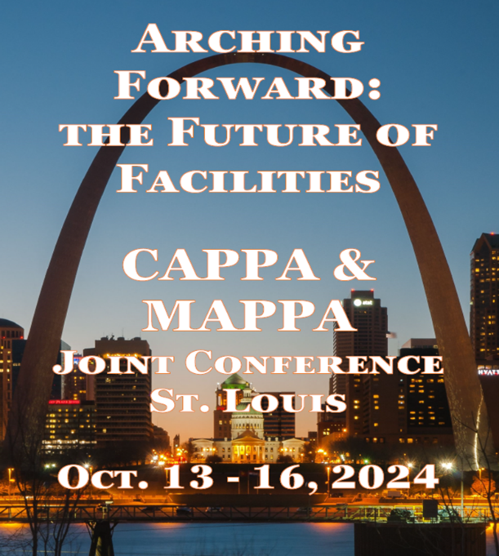
The Central and Midwest regions of APPA, are excited to announce the 2024 CAPPA/MAPPA Joint Conference in St. Louis, Missouri. Together, we are "Arching Forward" into the Future of Facilities, and we want you to be a part of the experience!
Registration is now open for the
2024 CAPPA/MAPPA Joint Conference!
Sunday, October 13 – Wednesday, October 16, 2024
St Louis Union Station Hotel

Business Partners, this is an opportunity to build relationships with two large regions in APPA. If you are looking for an opportunity to expand your reach in higher education facilities – this conference is ideal for you! We will be offering dedicated exhibit hours, and our exhibiting Business Partners are welcome in every part of the conference, which will give them greater opportunities to network.

Business Partner Fee Structure

Exhibitor - $1850
Includes 1 complimentary attendee

Sponsorships include recognition in conference materials and displays.

Bronze Sponsor - $2350
Includes 2 complimentary attendees

Silver Sponsor - $3000
Includes 2 complimentary attendees

Gold Sponsor - $4000
Includes 2 complimentary attendees

Platinum and Diamond Sponsors will be given preferential choice of booth position in the Exhibit Hall.
Platinum Sponsor - $5500
Includes 3 complimentary attendees

Diamond Sponsor - $7500
Includes 3 complimentary attendees

Additional Booth Attendees - $500
Business Partner Attendees without a Booth - $750

Questions can be directed to either the CAPPA Conference Coordinator, Sue-Anna Miller (sue-anna@utulsa.edu), or the MAPPA Conference Coordinator, Michelle Holstege (holstegm@gvsu.edu).

We hope to see you there!
Luis Morales, CAPPA President-Elect
Nicole Corll, MAPPA President-Elect

