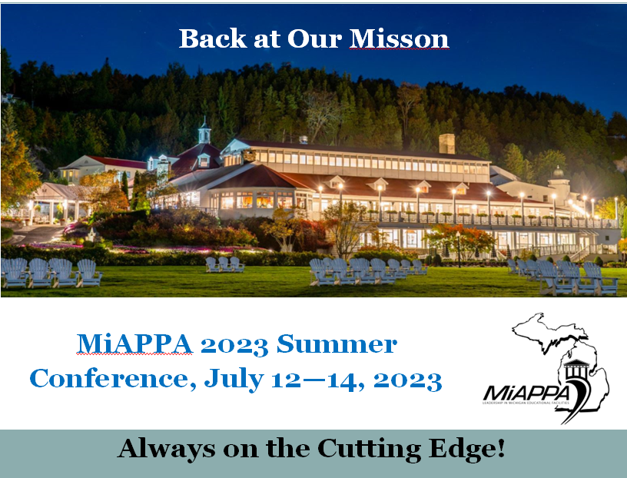
MiAPPA Conference Call for Proposals

Want to join over 250 active Michigan facilities professionals to showcase innovative practices, ideas and improvements you have implemented over the past year? Now is your chance! MiAPPA invites you to submit your proposal to share your best practices, innovative ideas, proven programs and projects with your facilities colleagues at the 2023 MiAPPA Summer Conference taking place on the historic Mackinac Island July 12 – 14, 2023.
The deadline for proposal submissions is Friday, April 14, 2023 by 11:59 p.m.
Theme: Back at Our Mission – Always on the Cutting Edge
People: Back at Our Mission for hiring qualified staff, serving our students with cutting edge methods and technologies. How we utilize creative schedules and contracts to coordinate the needs of the campus communities we serve.
Technologies: Back at Our Mission: Utilizing advanced technology in all aspects of the facilities operations. Grounds, Custodial, Maintenance, Energy.
Budgeting: Back at Our Mission: New expectations and budget realities. Creative ways to address post-pandemic expectations, increased costs and shrinking budgets.

Proposals should be a minimum of two of the noted topics and align with the theme stated above. Priority will be given to submittals that include demonstrated successes (case studies) and innovations that offer inspiration and excellence in addressing key challenges. Proposals should showcase the portability of these successes. If you have a topic that will be of significant interest to the audience, but may not align exactly with the theme, you are still encouraged to submit your proposal for review.

